Computer Science 222
Laboratory 2 –Arithmetic, Loops
Learning Objectives:
- Develop simple Python programs that do input, produce output and do arithmetic.
- Develop simple Python programs that use for loops.

Directed Activities:
1. Coffee shop. (Adapted, and modified, from the text, p. 76, Exercise 5)
Write a program, coffee.py, to compute the cost of coffee orders for customers. First ask how many coffee orders are to be processed. Each order costs $10.50 per pound. Each order ships for $0.86 per pound, and there is a fixed cost of $1.50 per order for overhead. For each order, ask the user for the number of pounds in that order then calculate and display the cost before proceeding to the next order.
Demonstrate for the instructor.

2. Computing the area of a triangle. (Adapted from the text, p. 77, Exercise 9)
Write a program, "triangleArea.py", to calculate the area of a triangle given the length of its three sides, a, b, and c, using these formulas:
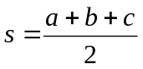 and 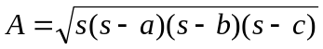
Demonstrate for the instructor.

3. Compute a square root. (Adapted from the text, p. 78, Exercise 17)
Write a program, newton.py, that approximates the square root of a number using Sir Isaac Newton's method. Ask the user what the number, x, is and how many times to improve the approximation. x / 2 is a good first approximation. Given an approximation,
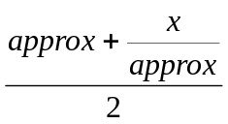

is a better approximation. Display the number and the final value of the approximation.
Demonstrate for the instructor.

4. Computing pi.
Write a program "pi.py" that approximates the value of using the Wallis formula:
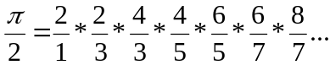

The program should prompt the user for n, the number of terms in the series, compute the product of the n terms, and output the resulting approximation of pi.
Demonstrate for the instructor.

5. Upload the files to your OAKS account.
coffee.py _______ triangleArea.py _______
newton.py _______ pi.py _______

6. If you left any files on the desktop, remove them. Log off of your computer.

